**Supporting integers**

**Adding support for more binary operators and adding precedence rules**

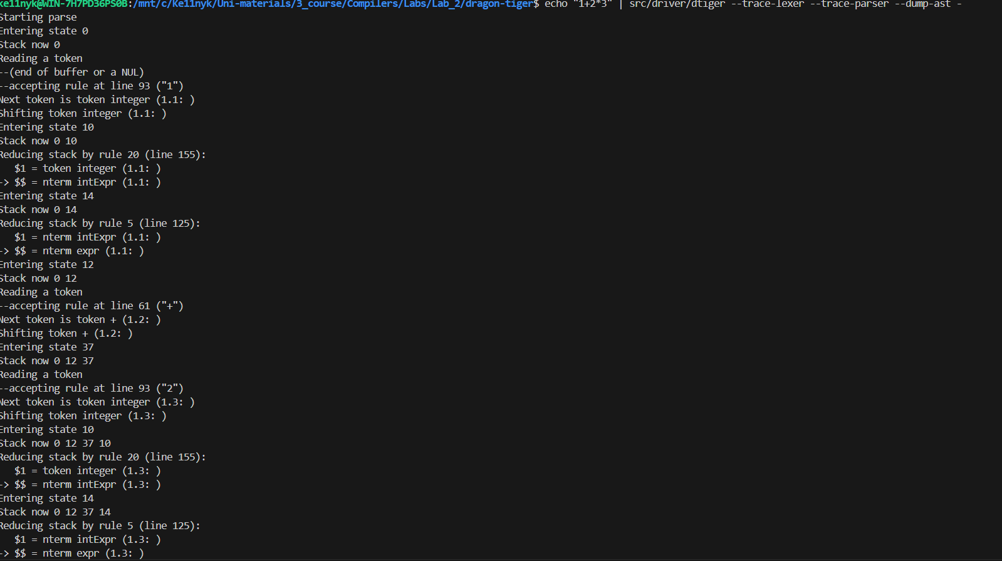

**Adding support for the Boolean OR operator**

**Adding support for if then else constructs**

**Implementing an AST evaluator for simple Tiger int expressions**



